CHAPTER 1

INTRODUCTION

**1.1 MOTIVATION**

In the present system, the records are maintained manually. The students are not aware of their academic status. So there is a need of automating the existing system by providing software solution for it. This provides transparency of information regarding academic and extra curricular activities. By visualizing and experiencing all these problems, we felt it would be better to provide a solution for this problem. This was the basis for taking up this problem.

**1.2 LITERATURE SURVEY**

**1)The System Analysis and Design of Student Management Information**

**ABSTRACT**

Student management as an important part of university management, and according to the actual situation of the school work, student management information system can not only improve the efficiency of staff and students, but also can be significant savings. In this paper, object oriented design methods are applied to the software systems. It uses Rose UML modeling to complete the requirement analysis of the student management system, and the functionality and performance analysis.

**CONCLUSION**

Student information management system is an information system about students’ all kinds of information management and analysis. It is an application of management information system in the field of teaching management. As an important part of university management, it plays an important role in the practical application. In this paper, student management system has conducted feasibility analysis, requirements analysis, functional analysis and performance analysis, and will lay a solid foundation for a future system development and implementation in order to achieve the overall management of the campus students and to promote the work of student management scientific, standardized, information and high efficiency.

**2)Design of Comprehensive student information system(SIS) And user interface for the honors college at USF**

**By - Sean M. Motta Advisor: Ms. Sharon Geiger**

**ABSTRACT**

The creation and management of accurate, up-to-date information regarding a student’s academic career is critically important in the management of a university. Previously, the USF Honors College relied heavily on paper records for this initiative. This research focuses on the design and implementation of a comprehensive student information system and user interface to replace the current paper records. Honors College Staff are able to directly access all aspects of a student’s academic progress through a secure, online interface embedded in the college’s website. The system utilizes user authentication, displaying only information necessary for an individual’s duties. Additionally, each sub-system has authentication allowing authorized users to create or update information in that sub-system. All data is thoroughly reviewed and validated on the server before actual record alteration occurs. In addition to a staff user interface, this system features a student user interface, allowing users to access information and submit requests electronically, saving both completion and processing time. All data is stored securely on SQL servers managed by the USF IT department. Standard best practices are employed throughout the system to ensure the highest possible level of security and standardization. The system features a complex logging system to track all users’ access and ensure conformity to data access guidelines. This system is expected to increase the efficiency of the college’s record management thereby decreasing the work hours needed to access and deliver student records to users throughout the day, and again later to file these records. It is anticipated that this system will increase the efficiency of the department, and allow staff to better serve students.

**CONCLUSION**

The SIS system is expected to increase the efficiency of the college’s record management,

decrease time required to access and deliver student records, decrease data duplication, increase data integrity, increase user access and convenience, decrease time spent on non-value added tasks and increase ability of staff to better serve the student population.

**3)Design and Implementation of Student Information Management System**

**By - ZhibingLiu**

**ABSTARCT**

This paper describes the system functional and architecture design, and emphasizes the system's functionality, database design and functional modules, etc. It uses Visual basic 6.0 version and SQL 2000 server Technologies. Main function is managing and maintaining information includes school roll information, curriculum information, class information and faculty information. Student Information Management System main features is information management including student, class, course, score, course selection and systems. The paper focuses on the function description and analysis of the system, and program access to the database through ODBC.

**CONCLUSION**

Old technologies are used Visual Basic 6.0 version and SQL 2000 version. You can greatly improve the efficiency of the code by calling module functions, variables in the project. As the system modules use varieties data in the database frequently it requires a public data manipulation function to perform a variety of SQL statements. The paper focuses on the function description and analysis of the system, and program access to the database through ODBC (Open Database Connectivity,), due to space constraints, the specific implementation process and program code give examples only.

**4)The Development and Design of the Student Management System Based on the Network Environment**

**By Zhi-gangYUE , You-wei JIN**

**ABSTRACT**

This paper does integration of student’s basic information and management information in to student management work in the college. The design includes client server programming through the input of the query conditions, the platform will create an Excel or Word report automatically for users to download. It has realized the online filing of student loans, difficulty student, scholarship etc.

**CONCLUSION**

The platform is not only convenient for the student management, but also enhances the students’ enthusiasm and initiative. The management information collection and storage provide an objective basis for the analysis and decision of school administrators. its success witnessed the accuracy and practicality of theoretical study. Although our college student management information maintenance level is still low which needs persistent efforts to solve the outstanding problems, actually we have made a primary success that will provide theoretical basis and actual combat experience to achieve a comprehensive information maintenance in colleges. Because of this, we also see that only the latest information technology and the most advanced management method can meet the requirements of the information development era, which will bring more benefits for the work of student management.

**5)Design and Implementation of College Student Information Management System based on the Web Services.**

**By TANG Yu-fang ZHANG Yong-sheng**

**ABSTRACT**

This paper introduces database design, specific realization of each function module and key technologies used in the system.This paper uses ADO.NET, RBAC and .NET technologies The system is mainly composed of seven function modules such as the students basic information management module, the score management module.This page achieves the Register and Login Authentication functions.The SIMS is developed by the design of database SIMS. Mdf and the realization of each module’s function.

**CONCLUSION**

Through the system, students can input personal information into the database of college student information management system real-timely, accurately, and inquire personal information timely and easily. Thus, it reduces information input workload of administrators, and enables them to focus on information auditing and consulting. It also realizes the digitalization and networking of information management for college student, and promotes the management of college students to carry out high efficiently.

**6)Intelligent Student Information System**

**By - M A Norasiah and A Norhayati**

**ABSTRACT**

This project is aimed a designing the software to manage the students’ academic data such as their status (Pass, Fail, Probation, Addition, Dismiss) so that their GPA and CGPA can be generated. This information is useful for students to plan their academic performance in the next semester. The system will also enable the Head of programs, the Academic Advisors as well as other faculty’s management teams to easily simulate the students’ study plan through user-friendly menu driven interface forms. The system is designed using visual basic programming and Microsoft access database program.

**CONCLUSION**

Intelligent Student Information System is the solution for the inefficient manual student’s data and study planning in faculty of Electronic & communication Engineering or any other branch in Engineering. This method will increase the efficiency of faculty’s student’s academic management as well as improving the current manual student’s data management. For the Head of the program and Academic Advisors, the system enables them to advise students better and most of all saves a lot of time calculating the GPA and CGPA manually. It is the hope that this project will help students by giving a consistent and competence guideline in order to manage their academic performance for the whole duration of their study in this Faculty.

**1.3 ORGANIZATION OF REPORT**

* Introduction in chapter 1 provides with a comprehensive introduction to Department Portal System (DPS). It includes the motivation for the project and literature survey.
* Requirement analysis in chapter 2 describes the existing system for monitoring the department and problems in the existing system. It includes problem definition of the application we have developed.
* Proposed model in chapter 3 describes the modules and their interactions using an interaction diagram and also defines the complete work of each model .
* Implementation in chapter 4 describes specific requirements , tools and programming languages used.
* Results in chapter 5 contain the screen shots of DPS outputs and database.
* Conclusion and future enhancements in chapter 6 is discussed.

**CHAPTER 2**

**REQUIREMENTS COLLECTION AND ANALYSIS**

2.1 EXISTING SYSTEM

In the present system, the records are maintained manually. The account details, all the payments and withdraws are entered manually which is prone to risk. The students are not aware of their academic status. The admin maintains details of students and staff and updates them manually periodically. Transcripts and report cards of students are prepared manually by the record officer and teachers. Attendance of students is recorded and displayed in order to control absentees and know the number of days that the student was absent. The attendance officer has to collect the attendance slip from the corresponding staff and compile it which is also a time taking process. In addition to that, retrieving records of students has been a difficult task and manual system also has difficulty of producing different reports which are required by the stake holders such as teachers, administrators or officials from the department. Access to library is one of the major time consuming process. The departments are using paper based documentation system for performing various tasks that does not utilize the current technology.

**2.2 LIMITATIONS OF EXISTING SYSTEM:**

* Manual management of most of the information
* Manual entrance of Attendance and IA Marks
* Limited articles can be display on Notice Board which does not ensure security
* Lack of mailing facilities
* Manual efforts in preparation of records
* Administrator or Staff has no facility to upload notice
* Access to information requires physical presence or via from others.
* Administrator cannot view student and staff details
* No online registration facility for subject and events

**2.3 PROBLEM DEFINITION:**

The main aim of developing this project is to automate the process of attendance, IA marks entry, transaction calculations, registration and display of any notice. It provides the students to view there IA marks and also their attendance status by logging in using username and password. It also provides facility for staff to keep track of student’s attendance and their IA marks. It provides a facility to students and staff to search for particular book and reserve them. The system generates automatic reports to keep track of the books in the library. The student are allowed to upload articles, notes, images etc which will be published on being approved by the staff. The notices may be related to academic or extra curriculum activities. A student can register for events only if his roll number and name is already present. The application also provides facility of leave management for staff and student. The department students can participate in office bearers election and cast vote. Users can communicate with each through mail, notices, chat, feedback and comments.

CHAPTER 3

DESIGN OF PROPOSED MODEL

Computers are used in almost every field. In order to take efficient use of these machines, all the present systems are being automated at a heavy rate. Moreover communication and data maintenance plays a very important role in his competitive world. In the view of making the system (Department) more efficient in maintaining, and communication, our project is a step forward to automate the process of the department works and provide various services.

This project consists primarily of six users:

* Student
* Staff
* Administrator
* Receptionist
* Librarian
* Focus Admin

**3.1 MODULES**

Our project has 6 modules as follows :

* Student
* Staff
* Administrator
* Receptionist
* Librarian
* Focus

**3.1.1 ADMINISTRATOR**

Administrator creates the account of staff by adding their details and categorizes them based on their roles. He can view all the details of the staff, but cannot change their details. He can also upload and view the notices. He processes staff’s and student’s leave requests. He also maintains transaction details of the department account.

**Task Performed by Administrator:**

* Creates staff account
* View details of staff
* Maintains transaction details
* Add company details
* Add recruited students details
* Manage staff leave requests
* Manage student leave requests
* Meeting management
* Add and view notice
* Compose and view mail
* Change his password

**3.1.2 RECEIPTIONIST**

Receptionist has the privilege lesser than the administrator. He creates the account of students by adding their details. But he cannot change their details. He also adds details of subject and concerned faculty.

**Task Performed by receptionist :**

* Add subject details
* Assign faculty to a subject
* Creates the account of student
* Add student details
* Add student dependent & residence details
* Add student education details
* Add student roles
* Upload and view notice
* Compose and view mail
* Change password

**3.1.3 STAFF**

Staff has the privilege greater than the student. Staff is registered first in order to use the services provided by the application. Staff is given extra permission for entering IA Marks, attendance, approving documents etc. His leave request is processed by admin.

**Task Performed by Staff:**

* View & update his profile
* Entry, update and view IA Marks
* Entry and view Attendance
* Generate attendance shortlist
* Approve and publish articles
* Request leave and view status
* Search & reserve books by authorwise and subjectwise
* Upload and view notice
* Compose and view mail
* Change password

**3.1.4 STUDENT**

Student is registered by receptionist. He can register for a subject after his name is enrolled in the department. He has the permission to view his profile, IA Marks, attendance details which is relating to him only. He can only update his profile and change password.

**Task Performed by Student:**

* View & update his profile
* Subject registration
* Create and Upload documents
* View his IA Marks
* View his attendance status
* View staff on leave
* Request leave
* Search & reserve books by authorwise and subjectwise
* View notice
* Compose and view mail
* Chat
* Change Password

**3.1.5 LIBRARIAN**

Librarian is in charge of the library. He assigns card ids for staff and students. He issues requested books based on FCFS. He also maintains reports of available and issued books.

**Task Performed by librarian:**

* Creates library account of student and staff and maintains them
* Add book’s details
* Checks the requested books by staff and student
* Issues the requested books by staff and student
* View available books
* Check library reports
* Search books : authorwise and subjectwise
* Upload and view notice
* Change password

**3.1.6 FOCUS**

Focus is the department’s student association. Any user can login to focus without authentication. It provides the following facilities:

* Display event details, results and related contact details
* Event registration
* Display election details
* Display nominees and results of election
* Online voting
* Display placement(company details, recruited list) details
* User can upload articles
* User can provide feedback

**Focus admin** is under admin who maintains and controls details of department’s co-curricular activities.

**Task Performed by focus admin:**

* Add and update event details
* View event registration
* Add event results
* Add event contact results
* Add election details
* Add and view nominees
* Add and view election results
* Approve and publish articles
* View and reply feedbacks
* Change password

**3.2 INTERACTION DIAGRAM**

**3.2.1 ER DIAGRAM**

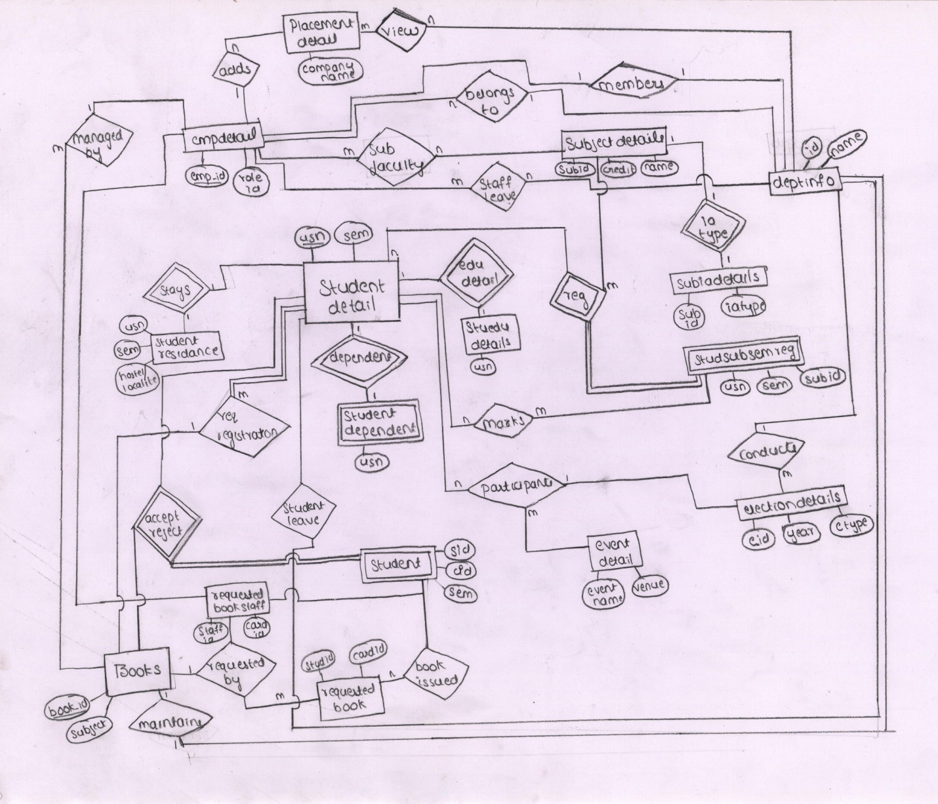

**3.2.2 DATA FLOW DIAGRAM**

Data Flow Diagrams are used to describe and analyze the movement of data through a system. DFD’s are used to capture the essential feature of both existing real system and future physical implementation of the system.

DFD is a graphical technique that depicts the information flow and transforms as data moves from input to the output. DFD is also known as Bubble Chart or Data Flow Graphs or Context diagram.

The data flow diagram may be used to present a system or software at any level of abstraction. A fundamental system model or a context model represents the entire software elements as a single bubble with input and output data indicated by incoming and outgoing arrows respectively.

LEVEL 1:

User

Login

Login Process

Re-login

**Figure 3.2.2.1 Level 1 DFD**

**LEVEL 2:**

Non Teaching staff

Librarian

Focus admin

Receptionist

Teaching staff

View

Add

Recruitment details

Company details

View

Add

Reject

Accept

Focus admin

Receptionist

Non Teaching staff

Librarian

Teaching staff

**Figure 3.2.2.2 Level 2 DFD- Admin**

View

Upload

Compose

Inbox

**Figure 3.2.2.3 Level 1 DFD- Receptionist**

View

Add

Update

View

Update

Search Book

Add

Reserve Book

View

Generate Short List

Download

Publish

Status update

View Status

Request

**Figure 3.2.2.4 Level 1 DFD- Staff**

By author

By subject

Search Book

Reserve book

Request

View Status

View

Update

Upload Post

Create new post

View

Article

Status

Update

Add

**Figure 3.2.2.5 Level 1 DFD- Student**

Books

Staff

Student

View

Edit

View

Edit

Add

Add

Student

Staff

View

By subject

Edit

Staff

Edit

Student

By author

View

Total books after issuing

Total books author wise

Total books subject wise

**Figure 3.2.2.6 Level 1 DFD- Library**

Add

View

Add Nominees

Election detail

Result

View Nominees

View

Download

Status Update

Reply

Publish

Contact Us

Event Details

View Registration

Results

Add

Update

**Figure 3.2.2.7 Level 1 DFD-Focus Admin**

Event details

Results

Contact Us

Reply

View

Nominees

Voting

Results

**x**

Create post

Upload

View

Add

Update

Status

Article

Company details

Recruitment details

**Figure 3.2.2.8 Level 1 DFD-Focus**

LEVEL 3 :

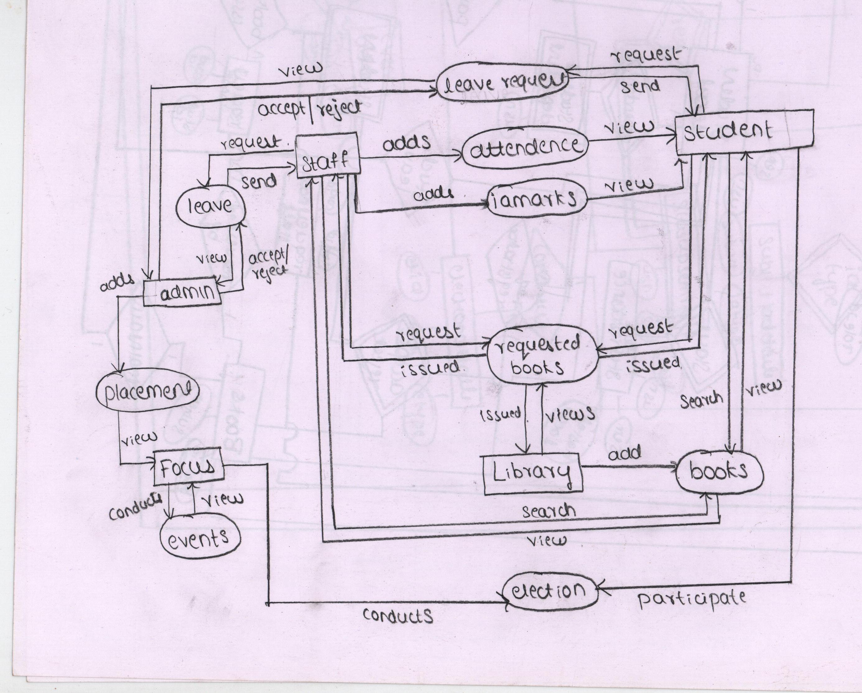

CHAPTER 4

IMPLEMENTATION

This specification is used to specify the requirements for the initial implementation of the system and update the system in future. The software requirement specification bridges the gap between client or the user and the system developer.

**4.1 SYSTEM DESIGN**

At the first level of system design, the focus is made on which module is needed for the system, the specifications of these modules, and how the modules should be interconnected.

In the second level, the internal details of each module are designed. The System design has a major impact on the testability, modifiability and efficiency of the system. A design methodology is a systematic approach to create a design by application of a set of techniques and guidelines. The design of the system is complete after enabling it to satisfy the requirement specification.

**4.2 Proposed model architecture**

**Three-Tier Architecture**

Three-tier architecture is a [client–server architecture](http://en.wikipedia.org/wiki/Client%E2%80%93server_architecture) in which the [user interface](http://en.wikipedia.org/wiki/User_interface), [functional process logic](http://en.wikipedia.org/wiki/Business_logic_layer) , [computer data storage](http://en.wikipedia.org/wiki/Computer_data_storage) and [data access](http://en.wikipedia.org/wiki/Data_access) are developed and maintained as independent [modules](http://en.wikipedia.org/wiki/Module_%28computing%29), most often on separate [platforms](http://en.wikipedia.org/wiki/Platform_%28computing%29). It was developed by [John J. Donovan](http://en.wikipedia.org/wiki/John_J._Donovan) in Open Environment Corporation (OEC), a tools company he founded in [Cambridge, Massachusetts](http://en.wikipedia.org/wiki/Cambridge,_MA). The three-tier model is a [software architecture pattern](http://en.wikipedia.org/wiki/Software_Architecture_styles_and_patterns). Apart from the usual advantages of modular [software](http://en.wikipedia.org/wiki/Software) with well-defined interfaces, the three-tier architecture is intended to allow any of the three tiers to be upgraded or replaced independently in response to changes in requirements or [technology](http://en.wikipedia.org/wiki/Technology). For example, a change of [operating system](http://en.wikipedia.org/wiki/Operating_system) in the presentation tier would only affect the user interface code. Typically, the user interface runs on a desktop [PC](http://en.wikipedia.org/wiki/Personal_computer) or [workstation](http://en.wikipedia.org/wiki/Workstation_%28computer_hardware%29) and uses a standard [graphical user interface](http://en.wikipedia.org/wiki/Graphical_user_interface), functional process logic that may consist of one or more separate modules running on a workstation or [application server](http://en.wikipedia.org/wiki/Application_server), and an [RDBMS](http://en.wikipedia.org/wiki/RDBMS) on a [database server](http://en.wikipedia.org/wiki/Database_server) or [mainframe](http://en.wikipedia.org/wiki/Mainframe_computer) that contains the computer data storage logic. The middle tier may be multi-tiered.

**The First Tier: Client Devices**

A client device is a piece of hardware that can communicate with SGD using a web browser and the Sun Secure Global Desktop Client (SGD Client). The web browser communicates with the SGD Web Server on the second tier and displays the webtop to users. The SGD Client communicates with SGD servers on the second tier and displays the applications that users run. The Adaptive Internet Protocol (AIP) ensures optimal network usage between the first and second tiers.

**The Second Tier: SGD Servers**

The second tier might contain a single SGD server, or many SGD servers configured to form an array. An SGD server is responsible for the following:

* Authenticating users when they log in to SGD
* Negotiating with application servers to authenticate users when they run applications, prompting users for passwords when necessary
* Causing the Sun Secure Global Desktop Client to display applications
* Keeping track of running applications even after users have logged out, so that they can resume them later

**The Third Tier: Application Servers**

An application server runs users' applications. When a user clicks a link on their webtop, SGD starts the application on an appropriate application server. Output from the application is redirected by the SGD server from the application server to the client device. When you tell SGD about an application, you include information about all the application servers that can run the application. SGD load balances between the application servers.

[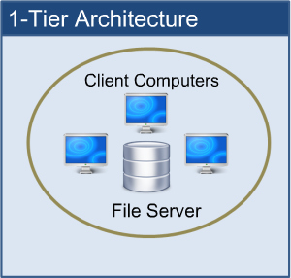](http://blog.simcrest.com/what-is-3-tier-architecture-and-why-do-you-need-it/1tier/) [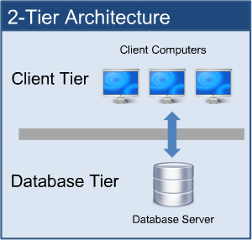](http://blog.simcrest.com/what-is-3-tier-architecture-and-why-do-you-need-it/2tier-2/) [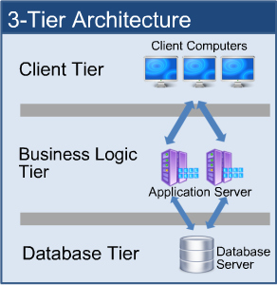](http://blog.simcrest.com/what-is-3-tier-architecture-and-why-do-you-need-it/3tier/)

**4.3 SPECIFIC REQUIREMENTS**

**4.3.1 EXTERNAL INTERFACE REQUIREMENTS**

**User Interface :** HTML , Dreamweaver , JavaScript , Flash5, Web style 4

**Software Interface :** JDBC-ODBC Driver

**4.3.2 HARDWARE AND SOFTWARE REQUIREMENTS**

**Hardware requirements:**

* + - Standard PC configuration
    - Hard Disk of 1GB

**Software requirements:**

* Windows 7/8
* Jdk 1.3 or higher
* Apache Tomcat
* mySQL
* Microsoft FrontPage/Dreamweaver
* Flash5

**4 .4 TOOLS AND PROGRAMMING LANGUAGES**

**4.4.1 HTML**

HTML means Hypertext Markup Language. HTML is a method of describing the format of documents which allows them to be viewed on computer screens. HTML documents are displayed by web browsers. HTML pages can be developed to be simple text or to be complex multimedia extravaganzas containing sound, moving images, virtual reality, and Java applets.

The global publishing format of the Internet is HTML. It allows authors to use not only text but also format the text with headings, lists, and tables, and to include still images, video, and sound within text. Readers can access pages of information from anywhere in the world at the click of a mouse-button. Information can be downloaded to the reader’s own PC or workstation. HTML pages can also be used for entering data and as the front-end for commercial transactions.

**Features of HTML:**

* It is not a programming language.
* It is not a data description language.
* It is simple to understand and implement.
* HTML constructs are very easy to comprehend, and can be used effectively by anybody.
* The methodology used by HTML to mark up information is independent of its representation on a particular hardware or software architecture.
* HTML syntax is a worldwide standard.

**4.4.2 JAVASCRIPT :**

JavaScript is Netscape's cross-platform, object-oriented scripting language. Core JavaScript contains a core set of objects, such as Array, Date, and Math, and a core set of language elements such as operators, control structures, and statements. It is mainly used here for validation purpose.

**Benefits of JavaScript:**

* It is widely supported in Web browsers.
* It gives easy access to the document objects and can manipulate most of them.
* JavaScript can give interesting animations without the long download times associated with many multimedia data types.

### 4.4.3 JSP (Java Server Page) :

JavaServer Pages(JSP) is a technology for development of web pages that support dynamic content which helps developers insert java in HTML pages by making use of special JSP tags, most of which start with<% and end with %>.

**Advantages of JSP:**

* Better performance and scalability than ordinary CGI scripts, because they are persistent in memory and multi-threaded.
* No special client set up is required.
* They have built in support for HTTP sessions, which makes application programming possible.
* They have full access to Java Technology-Network awareness, threads and database connectivity-without the limitations of client side application applets.
* They are automatically recompiled when necessary.
* They exist in the ordinary Web server document space, no special URL mapping is required to address them.
* JSP pages are HTML like they have greater compatibility with web developmenttools.

**4.4.4 Java Data Base Connectivity (JDBC) :**

Java Data Base Connectivity is a standard SQL database access interface providing uniform access to a wide range of relational databases. It also provides a common base on which higher-level tools and interfaces can be built. This comes with an “ODBC Bridge”. That bridge is a library, which implements JDBC in terms of ODBC standard API. The driver used here is JDBC-ODBC Bridge. Applets access database using a combination of the JDBC-ODBC Bridge and an ODBC driver.

##### **Why we need JDBC?**

* ODBC is not appropriate for direct use from Java because it uses a C interfaces.
* ODBC is hard to learn. It mixes simple and advanced features together, and it has complex options even for simple queries.
* A Java API like JDBC is needed in order to enable a “Pure Java“solution.
* When ODBC is used, the ODBC driver manager and drivers must be manually installed on every client machine.

**4.4.5 MySQL server**

**MySQL** is the world's second most widely used open-source [relational database management system](http://en.wikipedia.org/wiki/Relational_database_management_system) (RDBMS). MySQL is a popular choice of database for use in web applications. Applications which use MySQL databases include: [TYPO3](http://en.wikipedia.org/wiki/TYPO3), [MODx](http://en.wikipedia.org/wiki/MODx), [Joomla](http://en.wikipedia.org/wiki/Joomla), [WordPress](http://en.wikipedia.org/wiki/WordPress), [phpBB](http://en.wikipedia.org/wiki/PhpBB), [MyBB](http://en.wikipedia.org/wiki/MyBB), [Drupal](http://en.wikipedia.org/wiki/Drupal) and other software. MySQL is also used in many high-profile, large-scale [websites](http://en.wikipedia.org/wiki/Website), including [Wikipedia](http://en.wikipedia.org/wiki/Wikipedia), [Google](http://en.wikipedia.org/wiki/Google) , [Facebook](http://en.wikipedia.org/wiki/Facebook), [Twitter](http://en.wikipedia.org/wiki/Twitter), [Flickr](http://en.wikipedia.org/wiki/Flickr), and [YouTube](http://en.wikipedia.org/wiki/YouTube). MySQL is written in [C](http://en.wikipedia.org/wiki/C_(programming_language)) and [C++](http://en.wikipedia.org/wiki/C%2B%2B). Its SQL parser is written in [yacc](http://en.wikipedia.org/wiki/Yacc), but it uses a home-brewed [lexical analyzer](http://en.wikipedia.org/wiki/Lexical_analysis). Many [programming languages](http://en.wikipedia.org/wiki/Programming_language) with language-specific [APIs](http://en.wikipedia.org/wiki/Application_programming_interface) include[libraries](http://en.wikipedia.org/wiki/Library_(computing)) for accessing MySQL databases. These include MySQL Connector/Net for integration with Microsoft's [Visual Studio](http://en.wikipedia.org/wiki/Visual_Studio) and the JDBC driver for Java.

**Features :**

* Cross-platform support, [Triggers](http://en.wikipedia.org/wiki/Database_trigger), [Cursors](http://en.wikipedia.org/wiki/Cursor_(databases))
* Updatable [views](http://en.wikipedia.org/wiki/View_(SQL))
* [Information schema](http://en.wikipedia.org/wiki/Information_schema)
* Strict mode (ensures MySQL does not truncate or otherwise modify data to conform to an underlying data type, when an incompatible value is inserted into that type)
* Independent [storage engines](http://en.wikipedia.org/wiki/Storage_engine) and [SSL](http://en.wikipedia.org/wiki/Secure_Sockets_Layer) support
* Query [caching](http://en.wikipedia.org/wiki/Cache_(computing))
* Embedded database library
* [Unicode](http://en.wikipedia.org/wiki/Unicode) support
* [ACID](http://en.wikipedia.org/wiki/Atomicity,_consistency,_isolation,_durability) compliance when using transaction capable storage engines
* Commit grouping, gathering multiple transactions from multiple connections together to increase the number of commits per second.

**4.5 FUNCTIONAL REQUIREMENTS**

**STUDENT**

This user has the least privilege. Student can register for a subject only when administrator enters his/her roll number and name. Student has the permission to view his profile, view his IA Marks, attendance details. Thus the student has permission to view details, which is relating to him only. He/she has no permission to modify except registration and change password.

**STAFF**

Staff has the privilege greater than the student. Staff also is registered first in order to use the services provided by the site. Similarly as the case with student, the staff id and name must be entered by admin prior to registration. Staff has some extra work to do i.e. staff has been given extra permission like entering of IA Marks, attendance, approving documents etc. Thus the staff will be able to modify details of subject relating to their subject only. And staff can view details of all students and subjects.

**ADMINISTRATOR**

Administrator creates the account of staff. But he cannot change the details of them. He can view all the details if student and staff. He can also upload notices and delete them. He also maintains transaction details of the department account.

**RECEPTIONIST**

Receptionist has the privilege lesser than the administrator. He creates the account of students by adding their details. But he cannot change their details. He also adds details of subject and concerned faculty.

**LIBRARIAN**

Librarian has the authority of maintain library. He assigns card ids for staff and students. He issues requested books based on FCFS. He also maintains reports of available and issued books.

**FOCUS ADMIN**

Focus admin is the sub module of admin who maintains and controls details of department’s co-curricular activities.

**CHAPTER 5**

**RESULTS**

**5.1TEST CASES AND RESULTS**

**Login Form:**

**Test data:** Blank username.

**Expected result**: Message- Please fill out the field.

**Observed results**: Message is displayed.

**Test data**: Blank Password field.

**Expected result**: Message- Please fill out the field.

**Observed results**: Message is displayed.

**Test data**: Incorrect username or password.

**Expected result**: Message- Invalid Username

**Observed results**: Message is displayed.

**Test data**: Correct username and password.

**Expected result**: Display appropriate user account depending on login.

**Observed results**: Appropriate account displayed

**Change Password Form:**

**Test data**: Incorrect old password.

**Expected result**: Message- Check your old password.

**Observed results**: Message displayed correctly.

**Test data**: Different new password and retype password.

**Expected result**: Message- Check your new password.

**Observed results**: Message displayed correctly.

**Test data**: correct old password, new password and retype password.

**Expected result**: Message- Password changed.

**Observed results**: Message displayed correctly.

**Forgot Password Form:**

**Test data**: Incorrect username.

**Expected result**: Message- Username not found.

**Observed results**: Message displayed correctly.

**Test data**: Incorrect answer.

**Expected result**: Message- Check hint answer

**Observed results**: Message displayed correctly.

**Test data**: Correct answer.

**Expected result**: Message- Your password is: ________________

###### **Observed results**: Password displayed**.**

**Subject Registration Code Form:**

**Test data**: No. of subjects selected( equal to required credits)

**Expected result**: Message- Elective subject credits : no. of credits OK

**Observed results**: Message displayed

**Test data**: No. of subjects selected( less than required credits)

**Expected result**: Message- Selected subjects credits is less than max credits.

**Observed results**: message displayed

**Test data**: No. of subjects selected( greater than required credits)

**Expected result**: Message- Selected subjects credits is greater than max credits.

**Observed results:** appropriate message displayed.

**Test data**: Already registered

**Expected result**: Student already registered for subject: subject ID.

**Observed results:** appropriate message displayed.

**Voting Form:**

**Test data**: Incorrect password.

**Expected result**: Message- Check username or password.

**Observed results**: Message displayed correctly.

**Test data**: Correct password.

**Expected result**: Message- Appropriate form displayed.

**Observed results**: Election detail form displayed.

**Test data**: New voter.

**Expected result**: Message- Voting is done successfully , Thank you.

**Observed results**: appropriate message displayed.

**Test data**: Already voted student.

**Expected result**: Message- Sorry your voting power is already used.

**Observed results**: Empty form with appropriate message.

**5.2 DATABASE SCREENSHOTS**

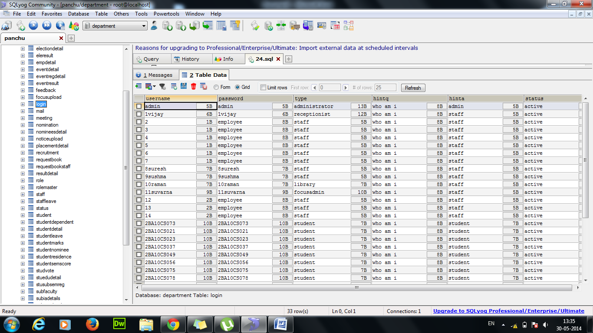

Figure 5.2.1 login table

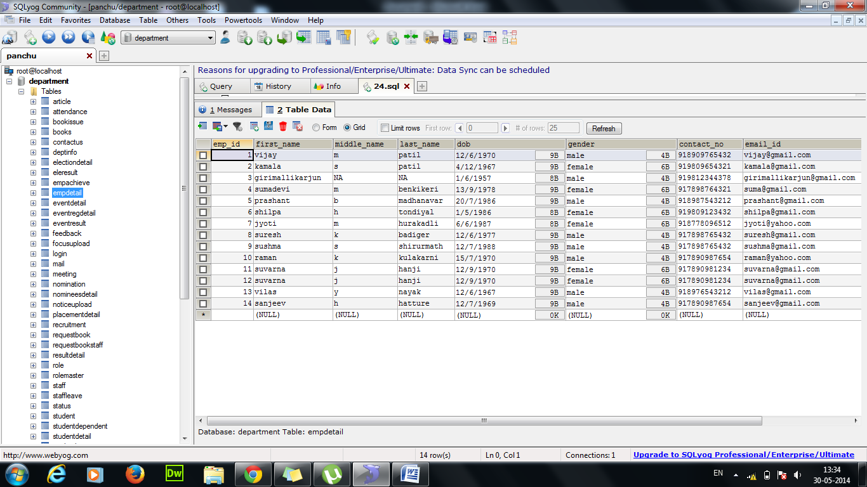

Figure 5.2.2 Employee detail table

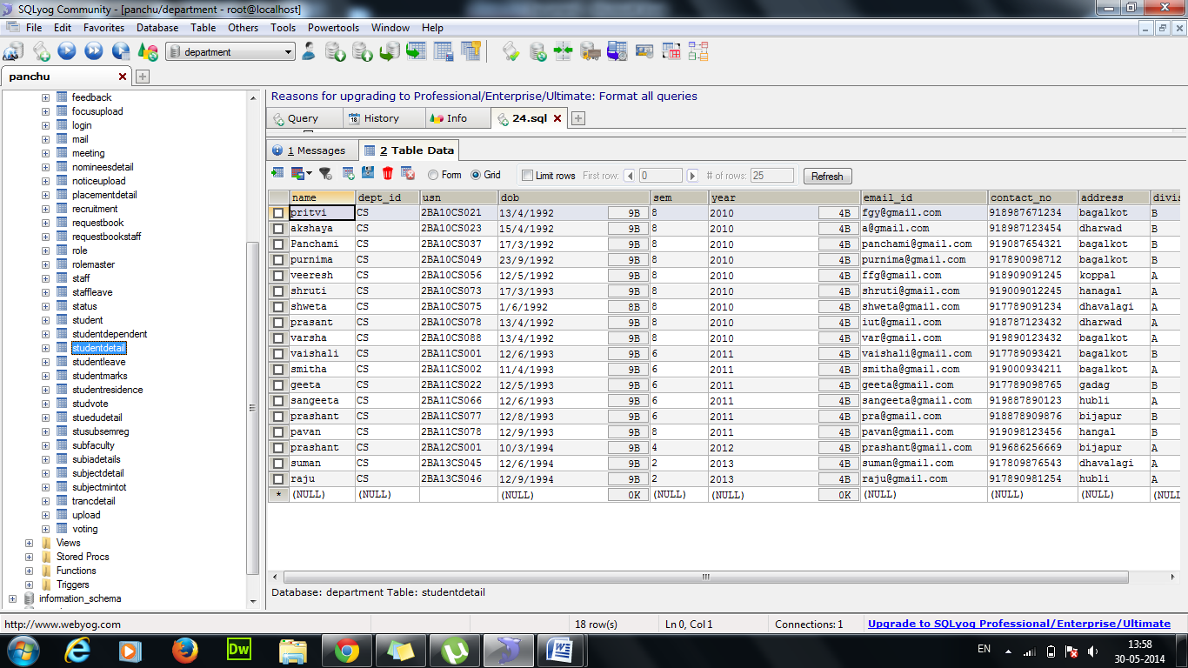

Figure 5.2.3 Student detail table

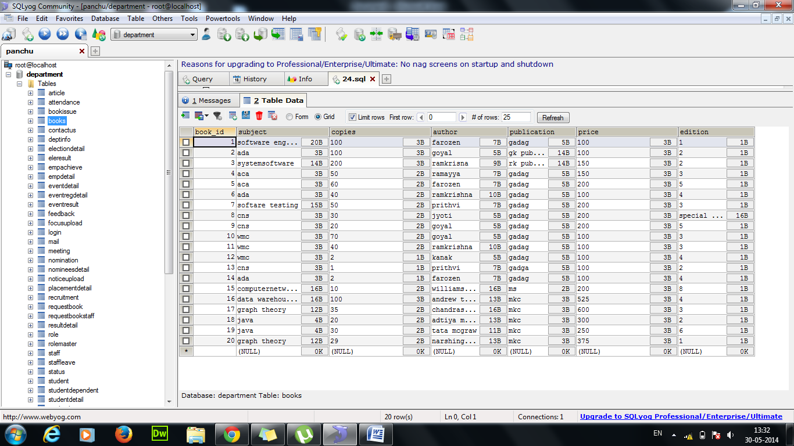

Figure 5.2.4 Books table

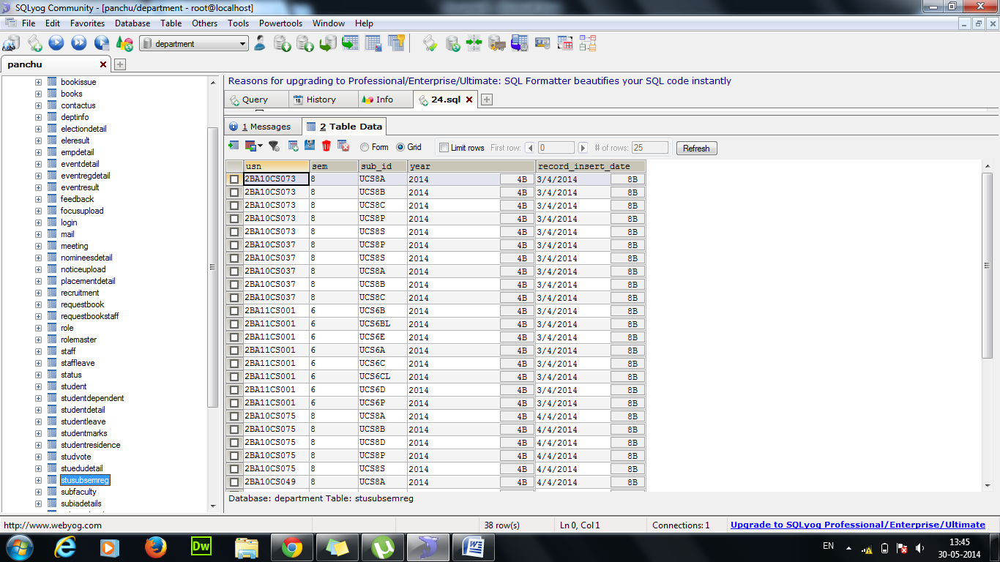

Figure 5.2.5 Student Subject Semester Registration

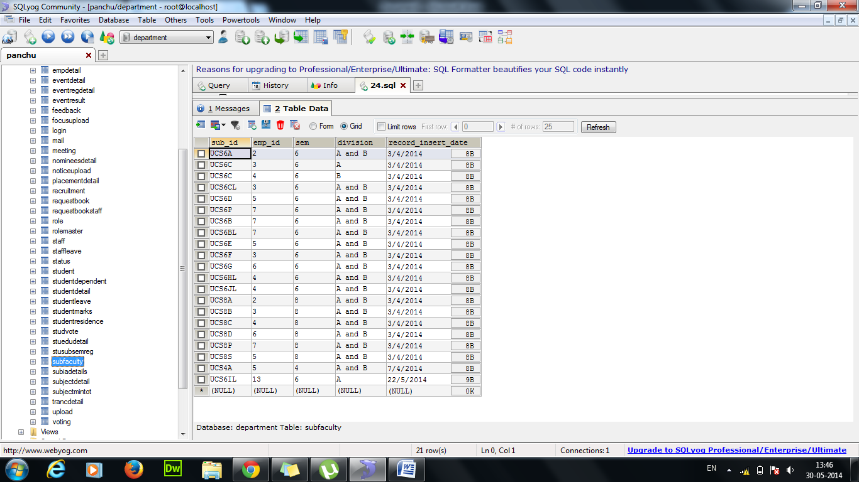

Figure 5.2.6 Subject faculty table

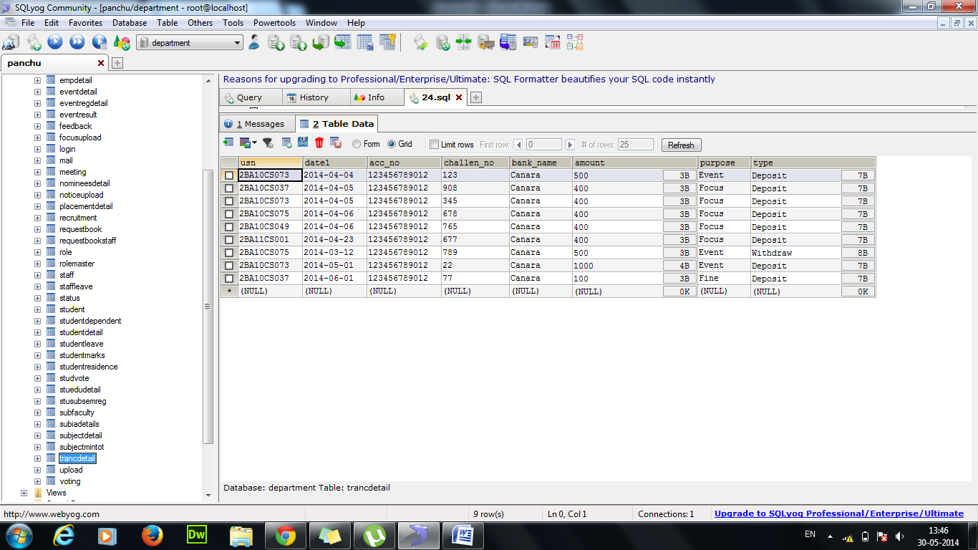

Figure 5.2.7 Transaction detail table

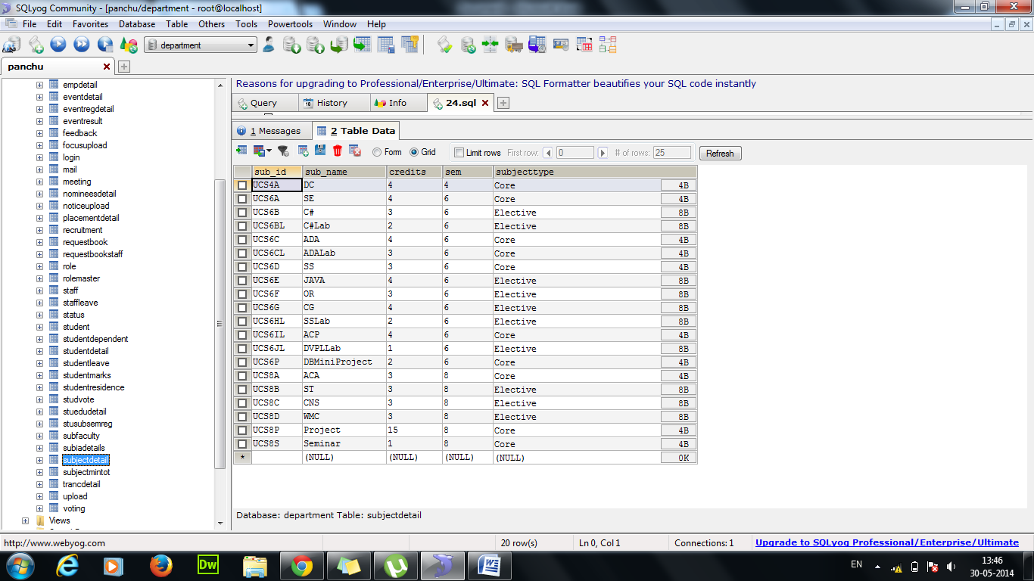

Figure 5.2.8 Subject detail table

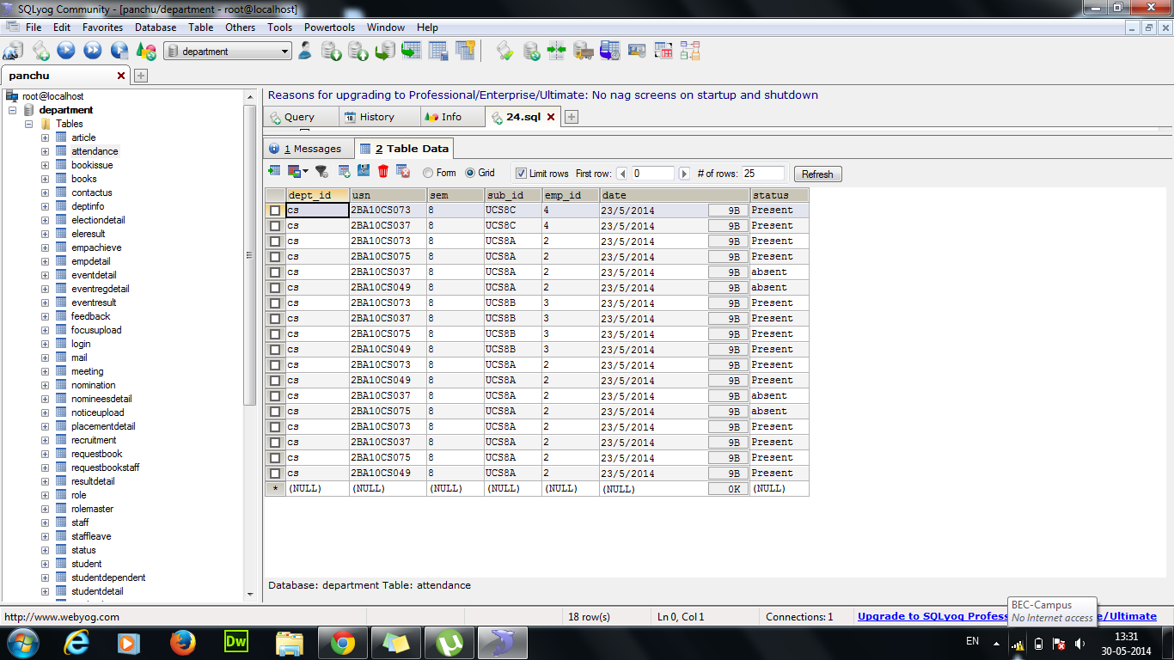

Figure 5.2.9 Attendance table

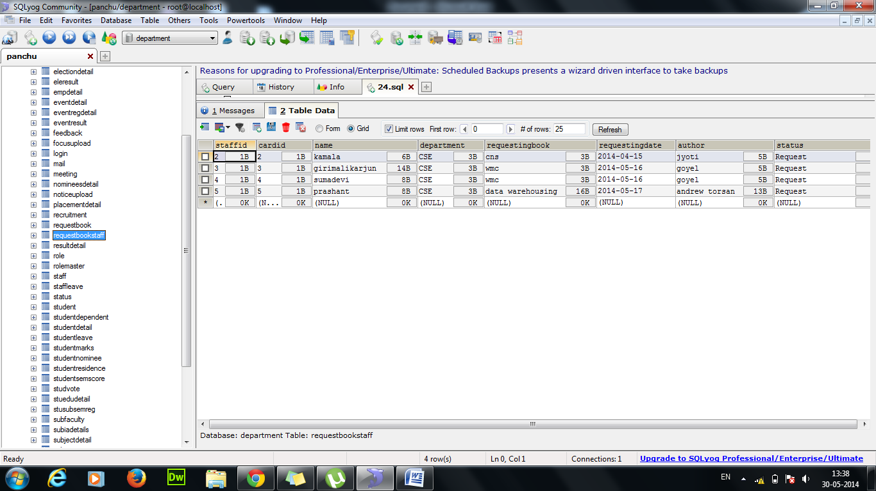

Figure 5.2.10 Request book staff table

**5.3 OUTPUT SCREENSHOTS**

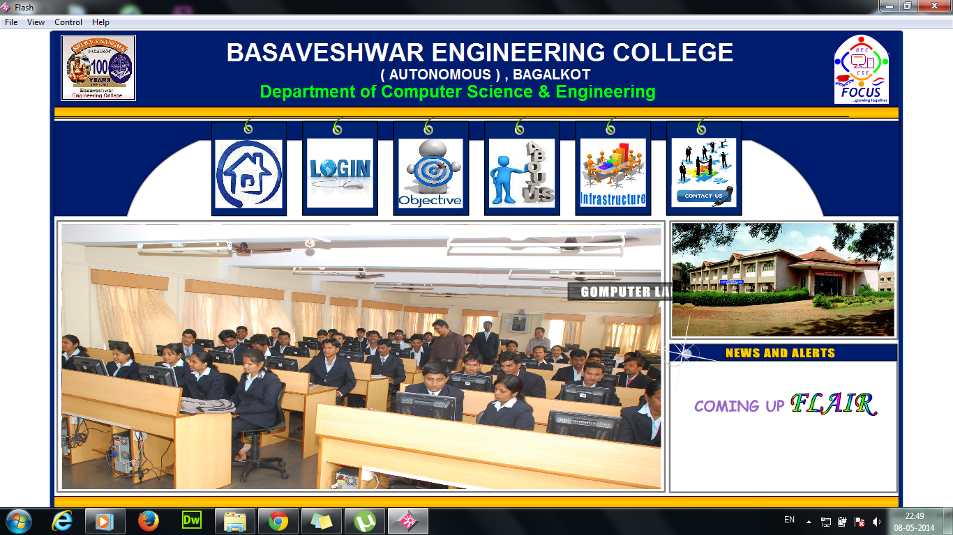

Figure 5.3.1 Homepage

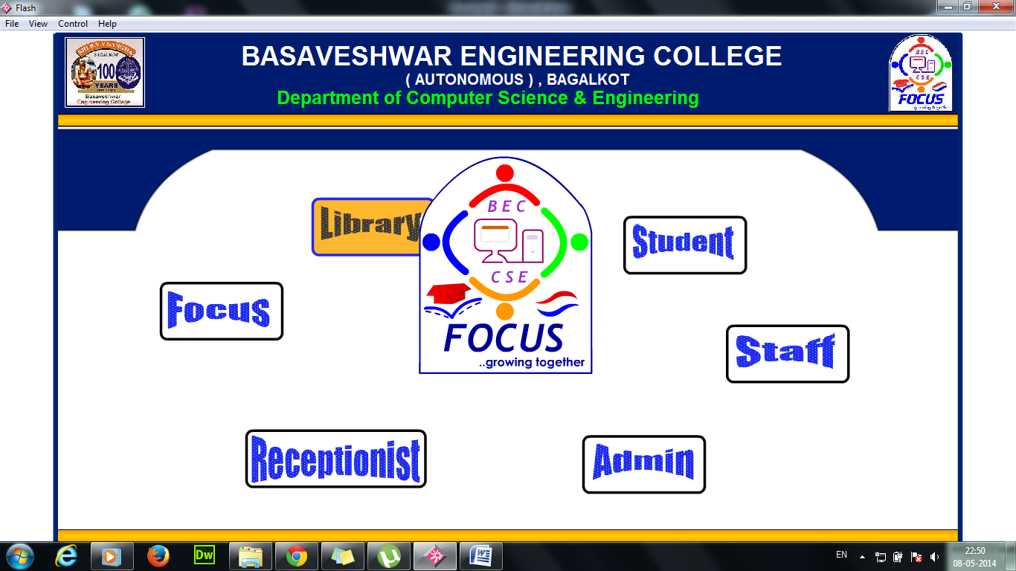

Figure 5.3.2 User login selection page

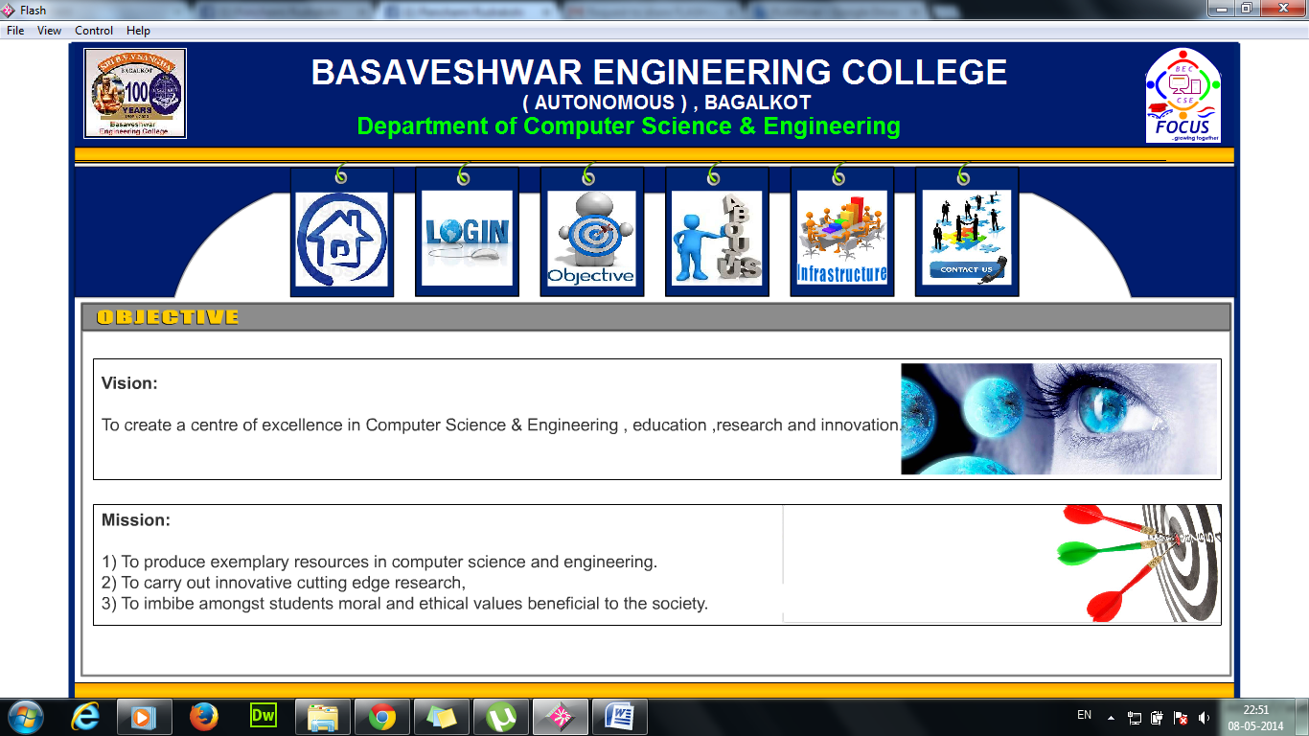

Figure 5.3.3 Objectives

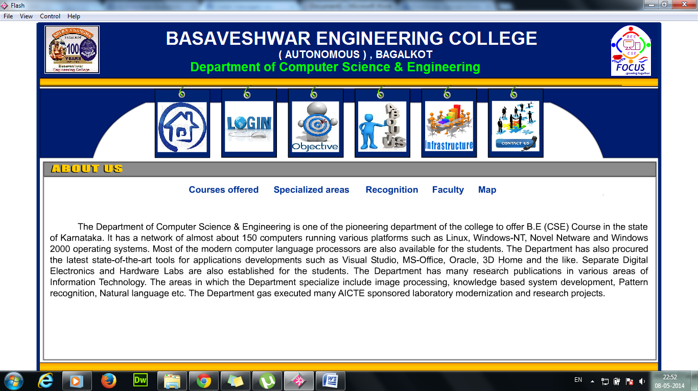

Figure 5.3.4 About Us

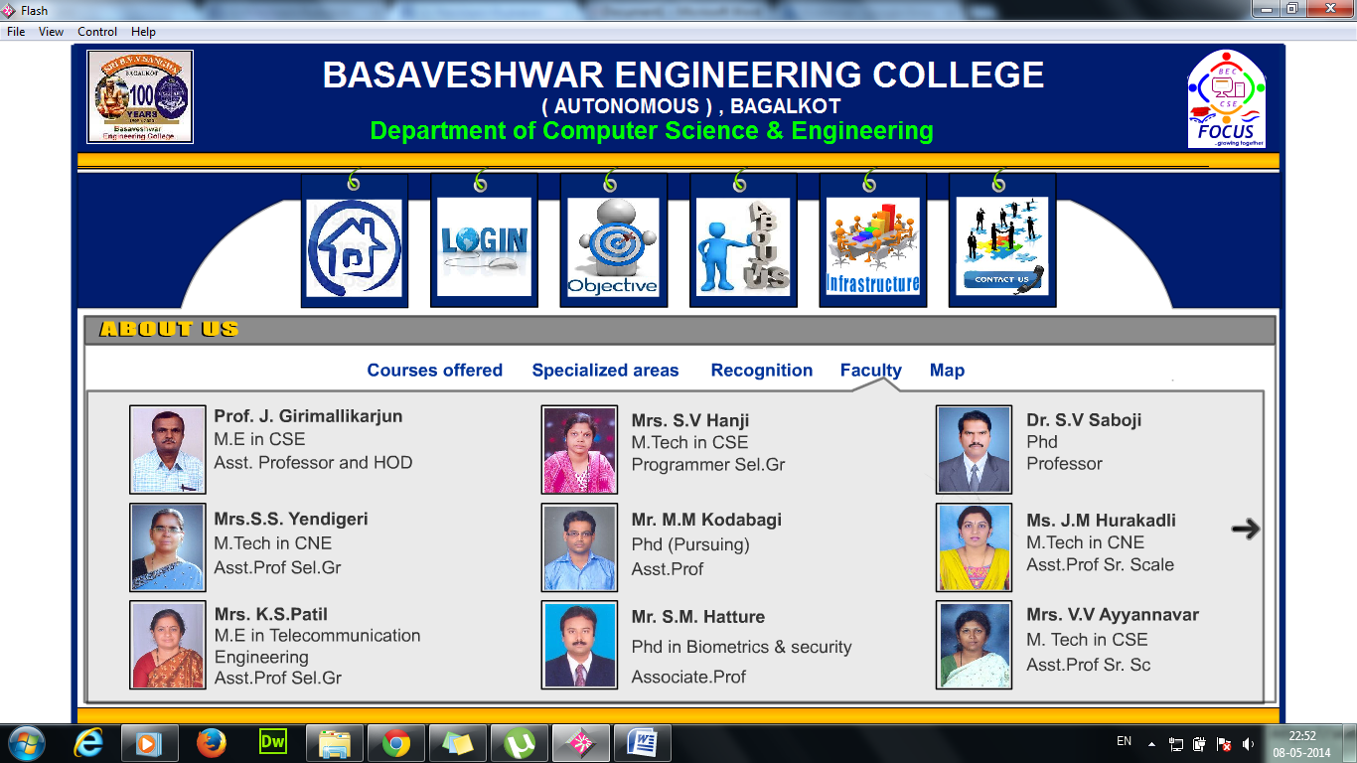

Figure 5.3.5 Faculty

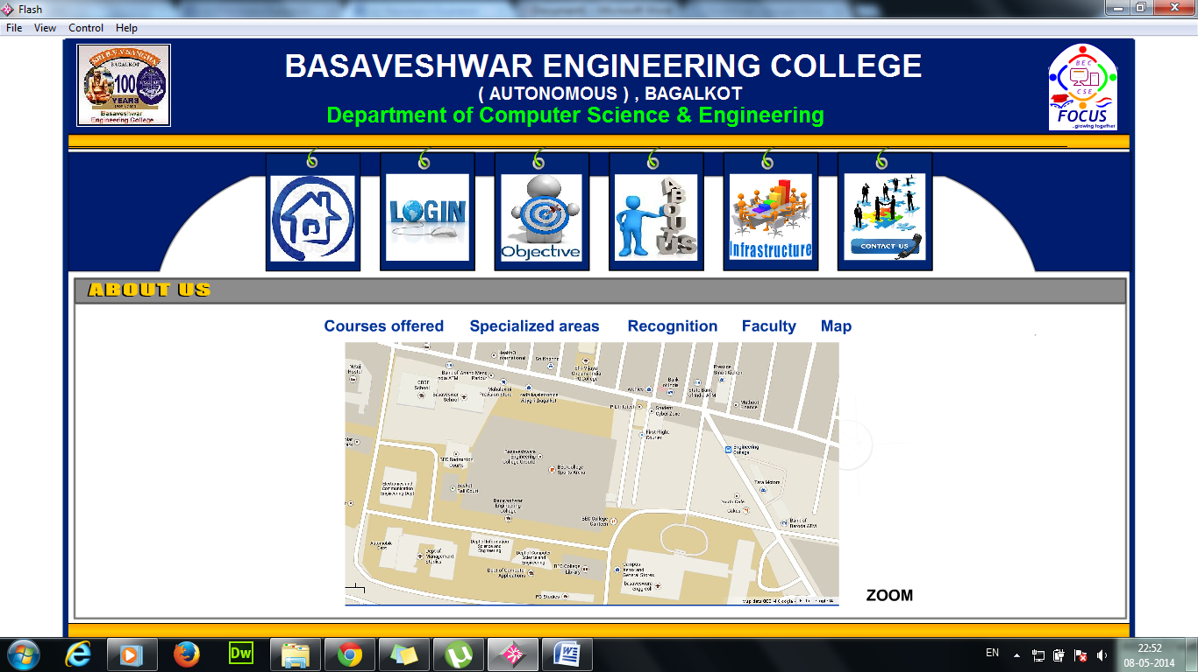

Figure 5.3.6 Map

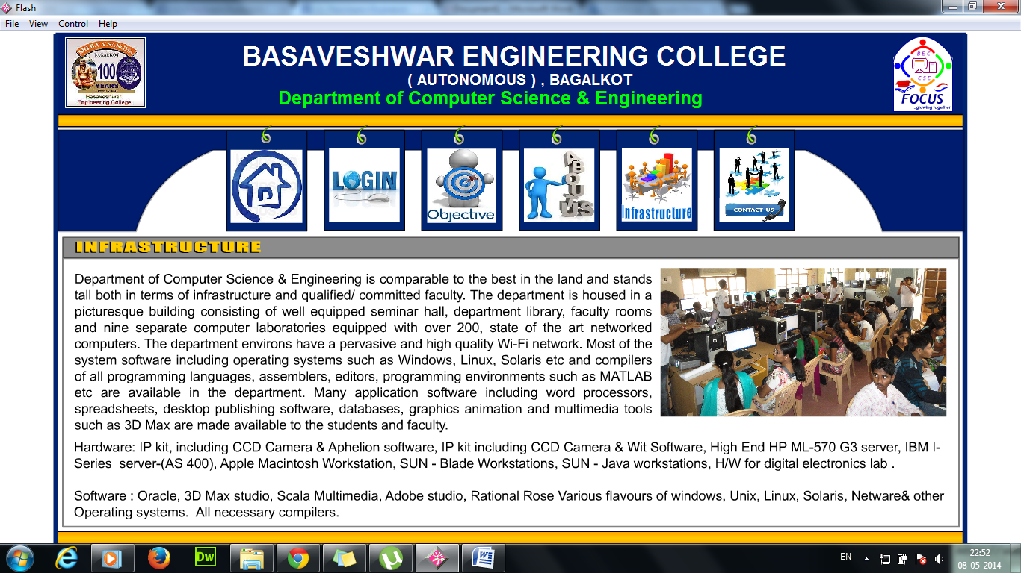

Figure 5.3.7 Infrastructure

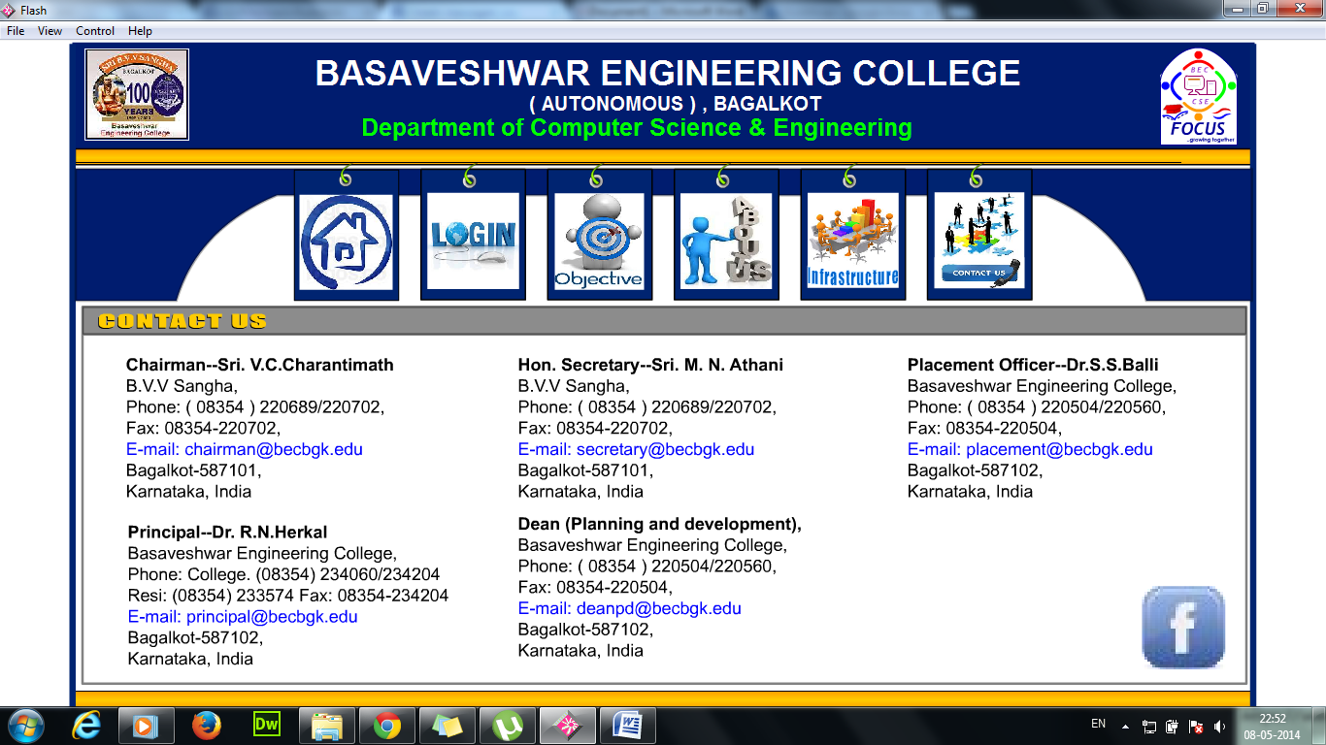

Figure 5.3.8 Contact Us

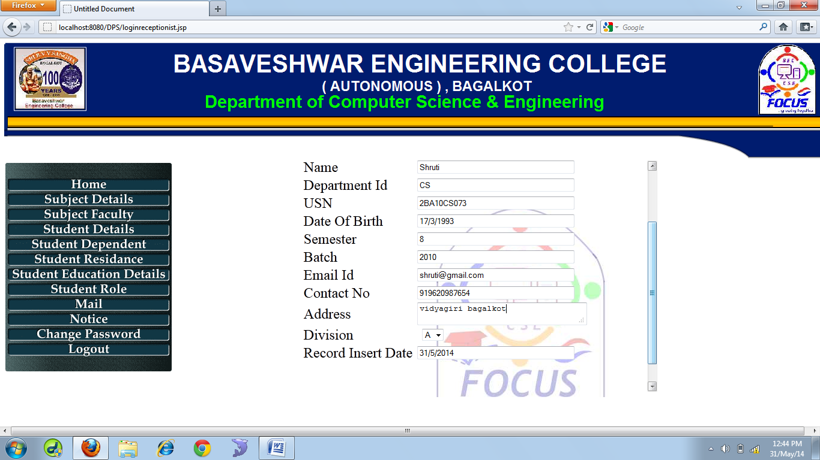

Figure 5.3.9 Student detail insertion form

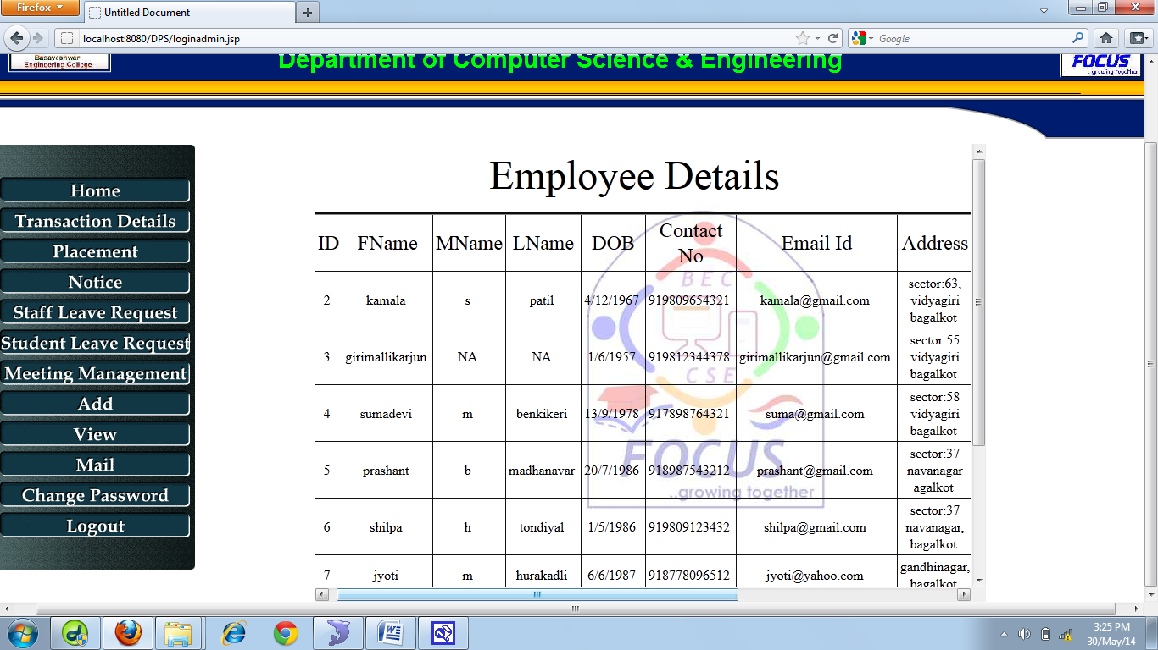

Figure 5.3.10 Employee details view form

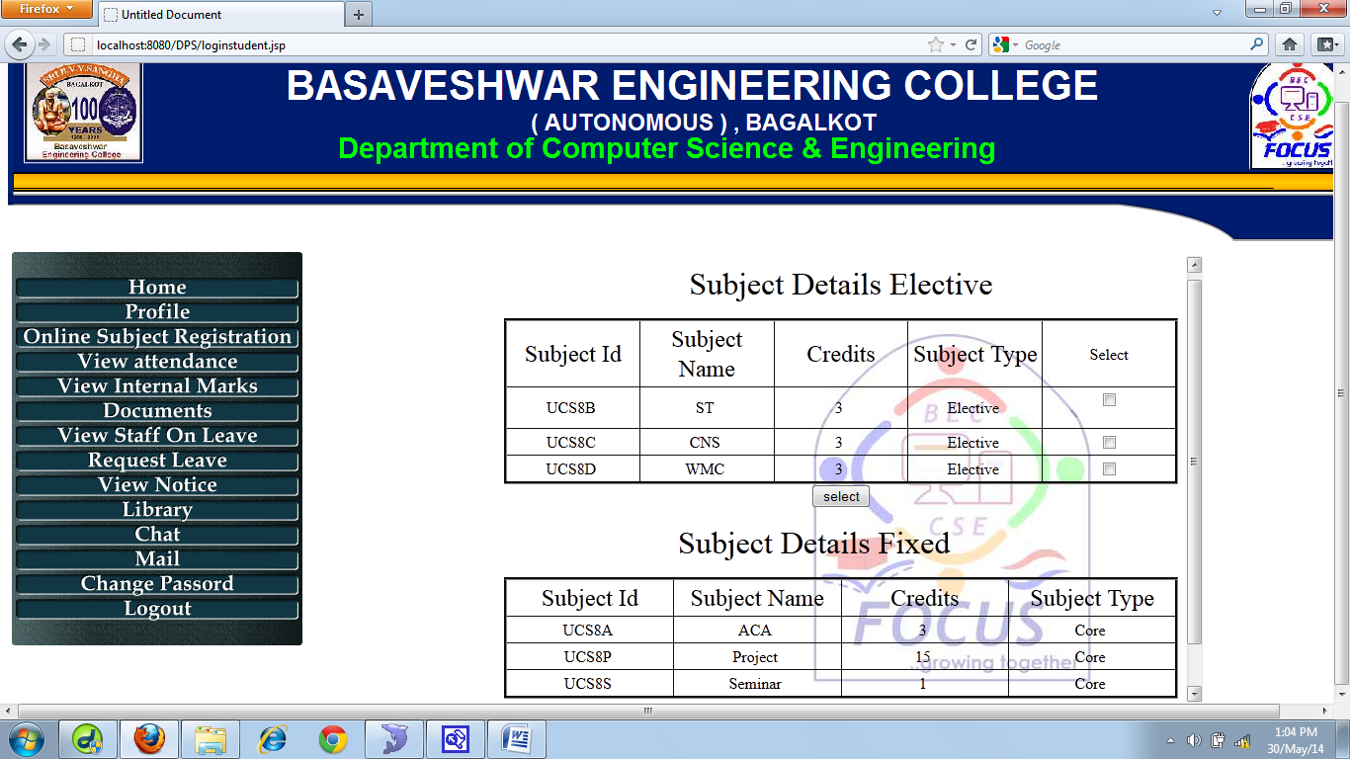

Figure 5.3.11 Online subject registration form

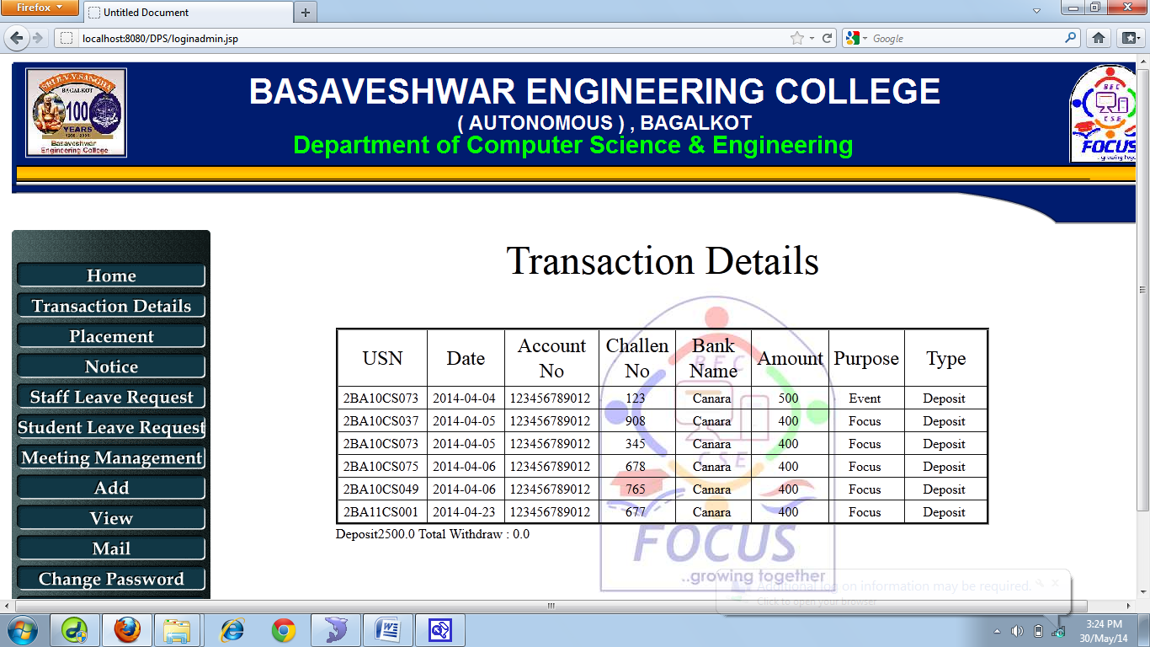

Figure 5.3.12 Transaction detail view form

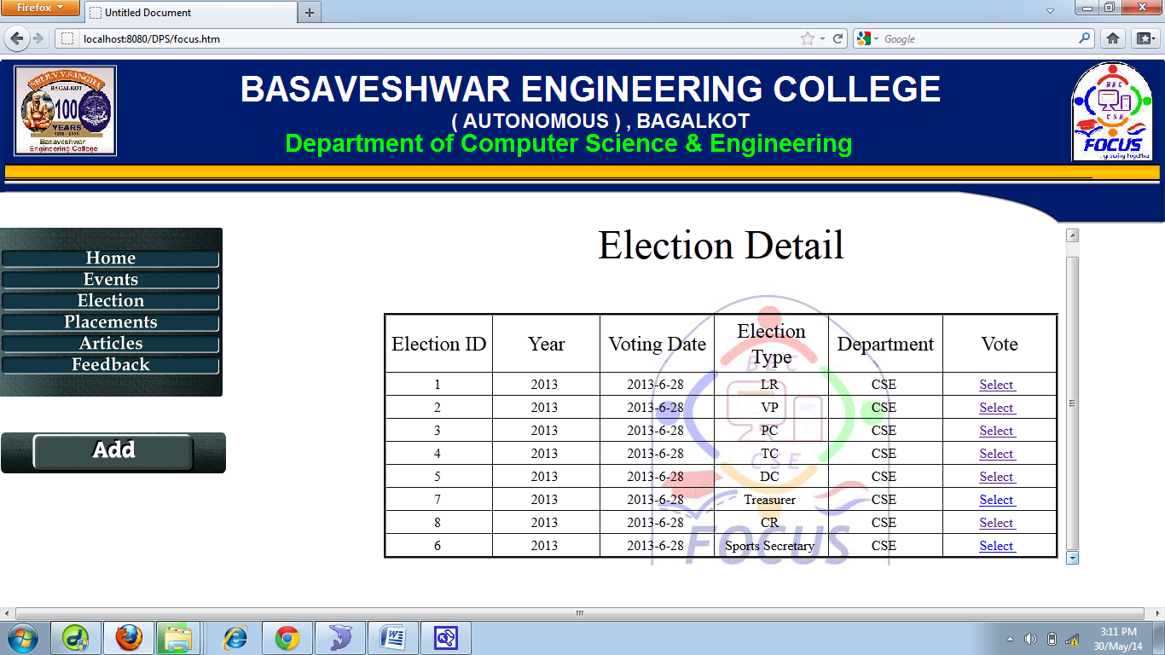

Figure 5.3.13 Election and voting form

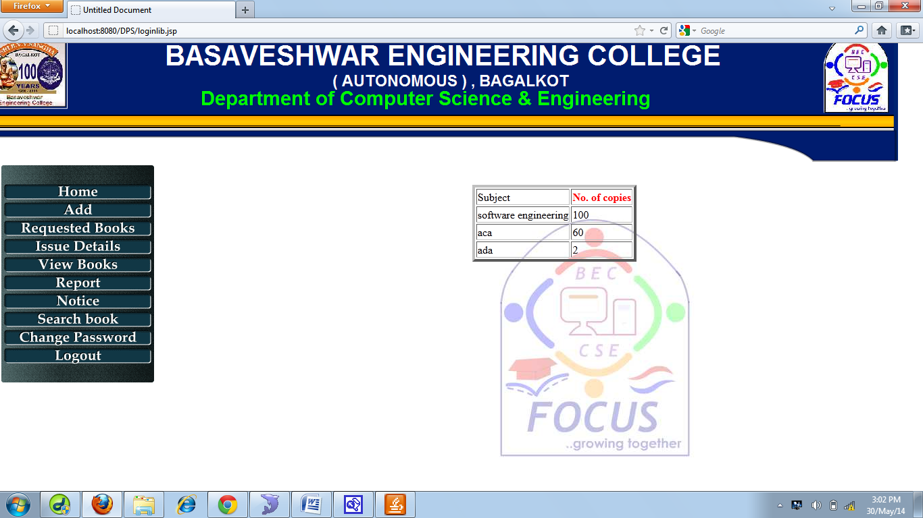

Figure 5.3.14 Search book (authorwise) form

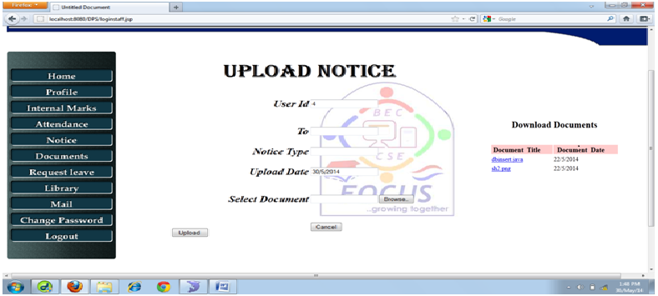

Figure 5.3.15 Notice upload form

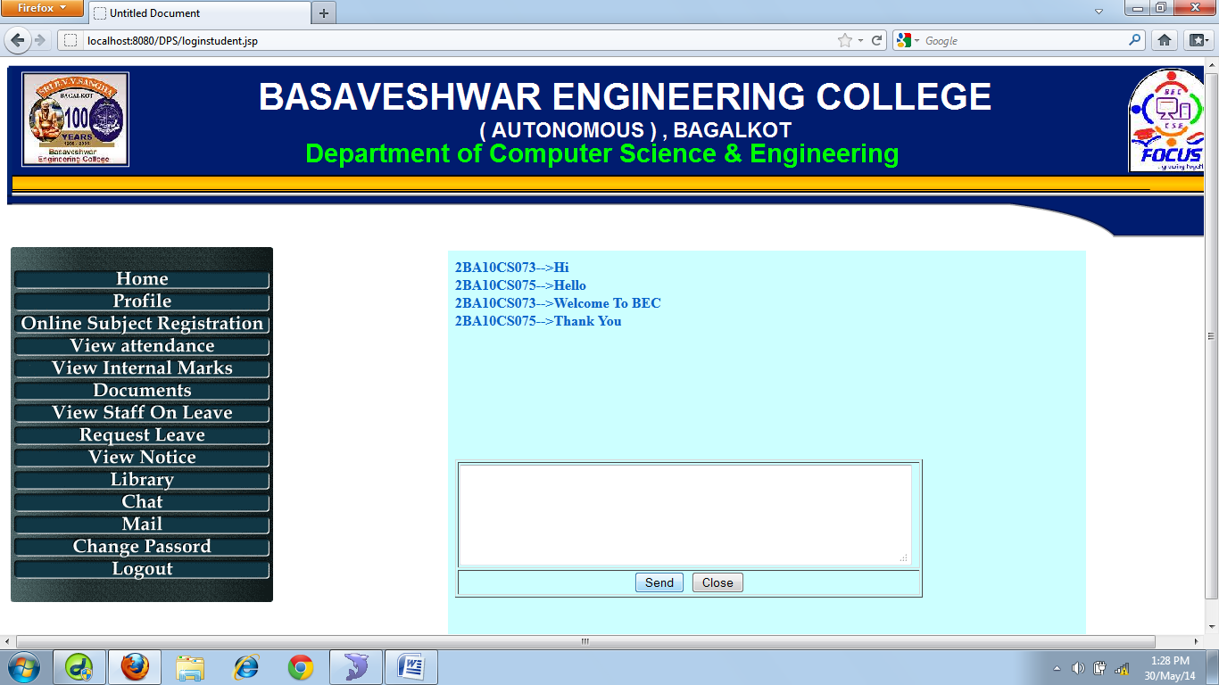

Figure 5.3.16 Chat form

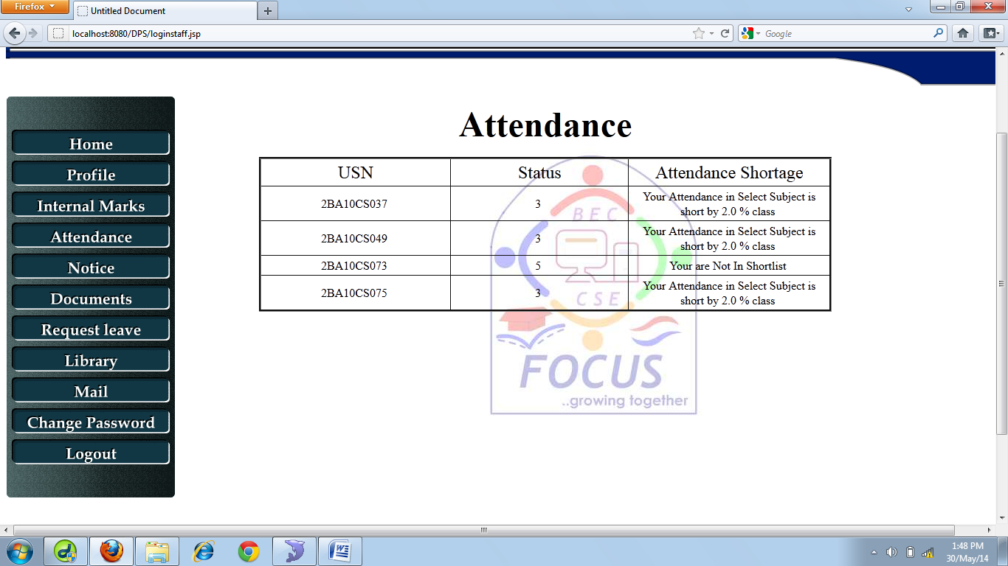

Figure 5.3.17 Attendance shortage form

CHAPTER 7

**CONCLUSION AND FUTURE ENHANCEMENTS**

**7.1 CONCLUSION**

Department portal system is a application that provides specific functionality and personalized capabilities for interaction between different user like between staff and student, among the staff, among the students and other users. The intention with which the project was started i.e. the automation of the marks entry and attendance entry is implemented. Notices and mail can be sent to respective users as and when required. Also various services like online event registration, subject registration, voting can be done successfully.

Department portal system increase the efficiency of the department’s record management, decrease time required to access and deliver student records, decrease data duplication, increase data integrity, increase user access and convenience, decrease time spent on non-value added tasks and increase ability of staff to better serve the student population.

Thus our project provides a user-friendly environment to carry out the departmental processes.

**7.2 Future Enhancements**

* Provision for withdraw a subject.
* Auto deletion of user account.
* Online generation of hall tickets and time table.
* Creating Alumni profile.
* Generation of semester end exam results.

**CHAPTER 8**

**REFERENCES**

* Design of a Comprehensive Student Information System (SIS) and User Interface for the Honors College at USF Sean M. Motta 1, 2 Advisor: Ms. Sharon Geiger 2
* Basic Web Design using Dreamweaver By Joseph M. Charnin September 10, 2007
* 3-Tier Architecture - Channu Kambalyal
* JavaTM 2 SDK, Standard Edition - Official site for JavaTM 2 SDK, Standard Edition
* Connector/J - MySQL Connector/J is the official JDBC driver for MySQL
* OVERVIEW OF JSP TECHNOLOGY-J2EE training from the author: <http://courses.coreservlets.com/>
* MySQL From Wikipedia, the free encyclopedia
* ADOBE DREAMWEAVER TUTORIAL
* The System Analysis and Design of Student Management Information

DU Xiaoming[a],*; FENG Fengjiao[a]